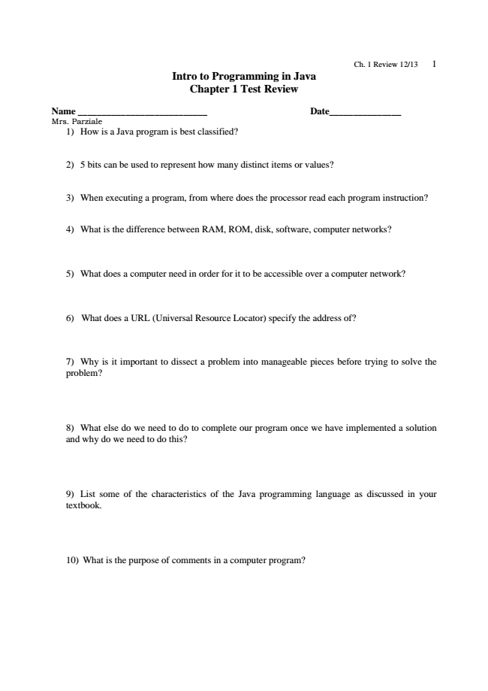

**Ch. 1 Review 12/13 1 Intro to Programming in Java Chapter 1 Test Review**

**Name ___________________________ Date_______________ Mrs. Parziale**

1) How is a Java program is best classified?

2) 5 bits can be used to represent how many distinct items or values?

3) When executing a program, from where does the processor read each program instruction?

4) What is the difference between RAM, ROM, disk, software, computer networks?

5) What does a computer need in order for it to be accessible over a computer network?

6) What does a URL (Universal Resource Locator) specify the address of?

7) Why is it important to dissect a problem into manageable pieces before trying to solve the problem?

8) What else do we need to do to complete our program once we have implemented a solution and why do we need to do this?

9) List some of the characteristics of the Java programming language as discussed in your textbook.

10) What is the purpose of comments in a computer program?

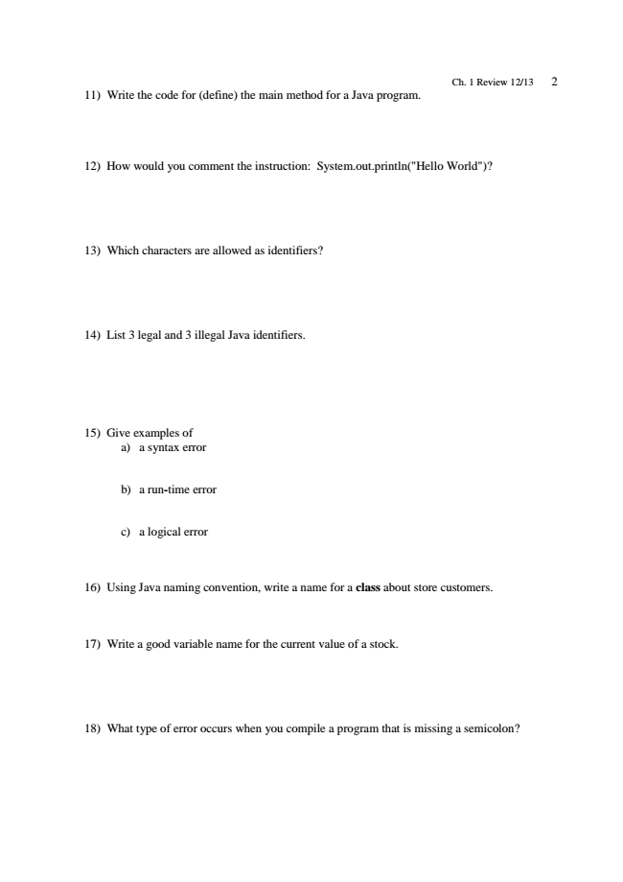

Ch. 1 Review 12/13 2 11) Write the code for (define) the main method for a Java program.

12) How would you comment the instruction: System.out.println("Hello World")?

13) Which characters are allowed as identifiers?

14) List 3 legal and 3 illegal Java identifiers.

15) Give examples of

a) a syntax error

b) a run-time error

c) a logical error

16) Using Java naming convention, write a name for a class about store customers.

17) Write a good variable name for the current value of a stock.

18) What type of error occurs when you compile a program that is missing a semicolon?

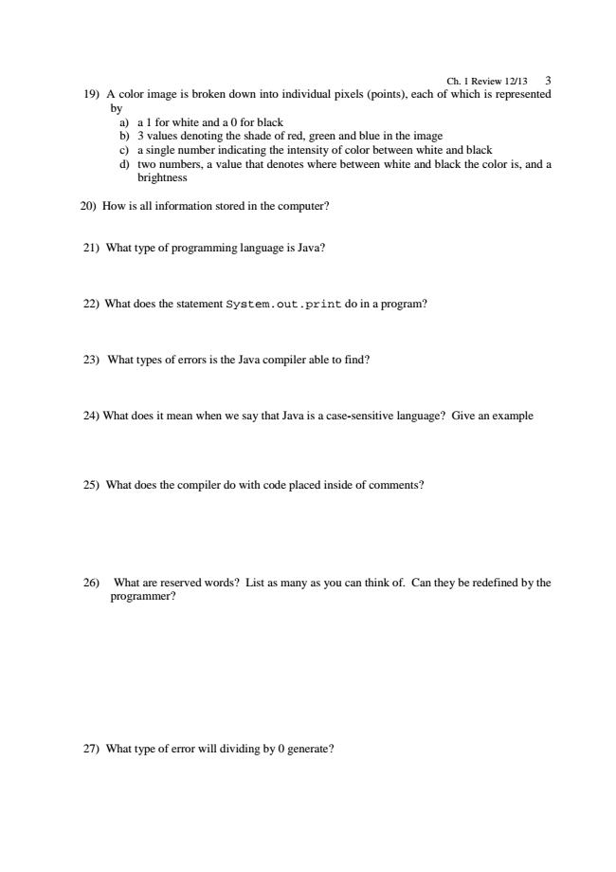

Ch. 1 Review 12/13 3 19) A color image is broken down into individual pixels (points), each of which is represented

by

a) a 1 for white and a 0 for black b) 3 values denoting the shade of red, green and blue in the image c) a single number indicating the intensity of color between white and black d) two numbers, a value that denotes where between white and black the color is, and a

brightness

20) How is all information stored in the computer?

21) What type of programming language is Java?

22) What does the statement System.out.print do in a program?

23) What types of errors is the Java compiler able to find?

24) What does it mean when we say that Java is a case-sensitive language? Give an example

25) What does the compiler do with code placed inside of comments?

26) What are reserved words? List as many as you can think of. Can they be redefined by the

programmer?

27) What type of error will dividing by 0 generate?

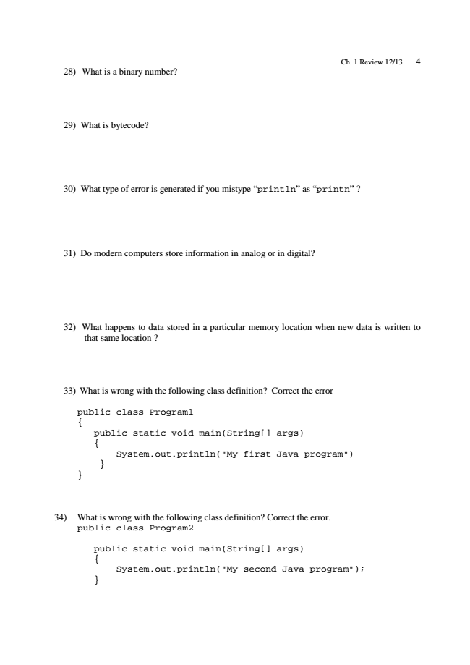

Ch. 1 Review 12/13 4 28) What is a binary number?

29) What is bytecode?

30) What type of error is generated if you mistype “println” as “printn” ?

31) Do modern computers store information in analog or in digital?

32) What happens to data stored in a particular memory location when new data is written to

that same location ?

33) What is wrong with the following class definition? Correct the error

public class Program1 {

public static void main(String[] args) {

System.out.println("My first Java program") } }

34) What is wrong with the following class definition? Correct the error.

public class Program2

public static void main(String[] args) {

System.out.println("My second Java program"); }

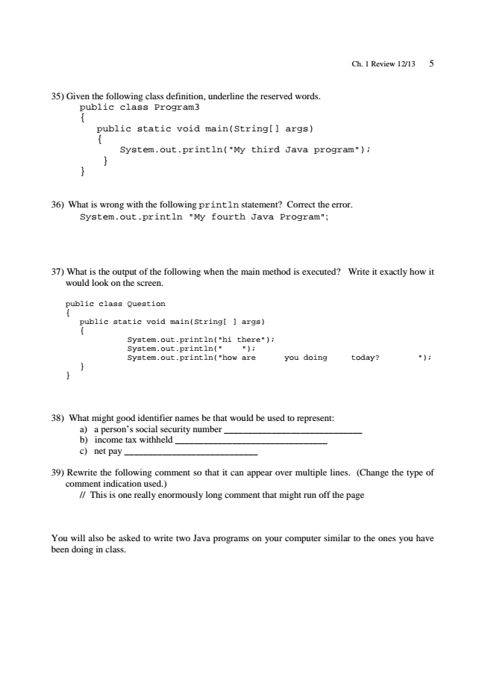

Ch. 1 Review 12/13 5

35) Given the following class definition, underline the reserved words.

public class Program3 {

public static void main(String[] args) {

System.out.println("My third Java program"); } }

36) What is wrong with the following println statement? Correct the error.

System.out.println "My fourth Java Program";

37) What is the output of the following when the main method is executed? Write it exactly how it

would look on the screen.

public class Question {

public static void main(String[ ] args) {

System.out.println("hi there"); System.out.println(" "); System.out.println("how are you doing today? "); } }

38) What might good identifier names be that would be used to represent:

a) a person’s social security number _____________________________ b) income tax withheld ________________________________ c) net pay ____________________________

39) Rewrite the following comment so that it can appear over multiple lines. (Change the type of

comment indication used.)

// This is one really enormously long comment that might run off the page

You will also be asked to write two Java programs on your computer similar to the ones you have been doing in class.